## STAKEHOLDER ENGAGEMENT & INVESTMENT ACTIVITIES IN 2017

#### Stakeholder Engagement

The construction of the windfarm began during the summer of 2017. The stakeholder meetings held in 2017 were delivered to explain to local communities the initial phases of the windfarm construction, i.e. the development of roads, the establishment of the construction site, and the overhead power line. Particular attention was paid to providing information to village authorities and residents prior to major increases in traffic or other project activities that could affect them. The information to be discussed was based upon the Transport Management Plan developed by WEBG, the EPC Contractor, the transport company and the highways police.

WEBG organized a total of 8 open door meetings in June and July 2017 (4 meetings per month), for the citizens of Mramorak, Bavanište, Dolovo, Vladimirovac and Devojački Bunar. Citizens were informed of the date and time of these meetings through invitation posters and by local community representatives. See the photolog below. It is noted that two further presentations will be held during the first few months of 2018.

The provision of information on the transportation of wind turbines is of great importance for the local community and the initial presentation took place in the village of Vladimirovac on 16 November 2017 at the elementary school. The title of the presentation was ''Presentation on special transport of wind turbines through Vladimirovac and additional security measures''. See the photolog below.

Citizens of Vladimirovac were told about the presentation through posters that were placed on several important locations in the village as well as the personal delivery of invitation letters for the citizens who live in the street Bratstva i Jednistva because it is considered that the transport will have the greatest impact on them.

The presentations were delivered by WEBG representative Mr. Aleksandar Andjic (Local Community Manager), representative of PMC Mr. Aleksandar Sotic (H&S Coordinator), as well as representatives of General Electric, Mr. Dusan Ilic (Site Manager), and Mr. Nemanja Milovanovic (Senior Mechanical Engineer).

The presentation was attended by 30 citizens from Vladimirovac. The topics covered in the presentation were:

* Information when the transport will start / photos of special transportation / planned number of trucks by the end of 2017.
* Indicative plan for transport by day / photos of trucks types.
* Detailed route plan from the Port of Pančevo to the construction site.
* H&S Instructions and recommendations / informational signs and warnings on and around the construction site.
* Requests and recommendations about transport - to remove any parked vehicles, bins and other assets during the turbines transport / to pay special attention that children do not leave unattended during the scheduled turbines transport.

The reaction from the attendees was very positive and they took a keen interest in the plans.

Questions and answers from the presentation was audio recorded and will be published on our website [www.wpc.rs](http://www.wpc.rs/) in February 2018 in a special text related to this event.

#### Social Investment Activities

Whilst the nature of social investment has changed as construction began, WEBG has continued to deliver our Social Investment Plan activities in parallel with the Stakeholder Engagement Plan and Environmental and Social Action Plan activities.

The Social Investment Plan for 2017 will include the following activities:

1. Working with the construction contractors to hire local workers, with preference for those who may be directly affected by noise, traffic, or other project activities.
2. Consider providing funding for local students’ university education in science and/ or engineering disciplines (e.g. ornithology).

It is noted that over 95% of the workers on the project were born and live in Serbia. In addition, WEBG have investigated the number of workers employed from the local villages and towns (i.e. from Deliblato, Mramorak, Banatsko novo selo, Pančevo, Bavanište, Dolovo, Kovačica, Debeljaca and Idvor). This number varies but is normally around 20.

The pre-operational bird and bat survey work will begin in the spring of 2018. It is expected that the search for a suitably qualified individual to continue this work in to the operational phase will start in the summer of 2018.

**Photolog and documentation**

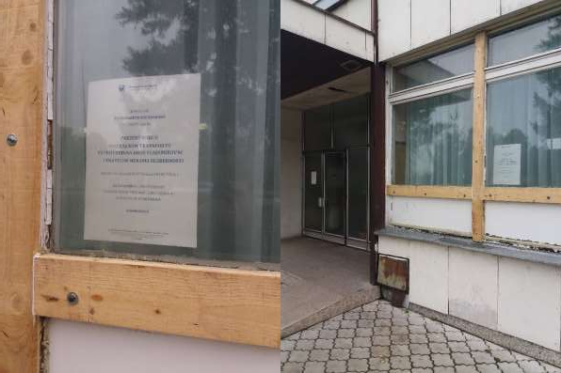

**Photo 1 – Placed posters in Vladimirovac**

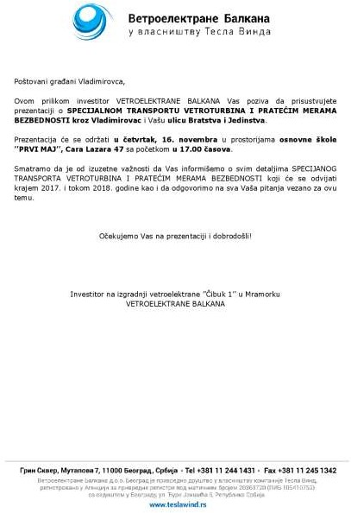

**Photo 2 – Invitation letter for residents of the street Bratstva i Jednistva**

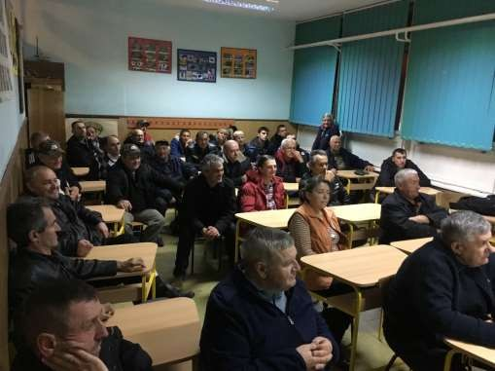

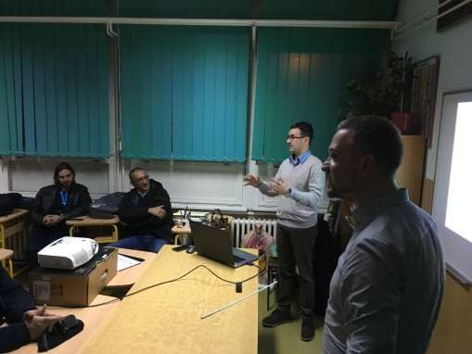

**Photo 3 – Photos from the presentation**

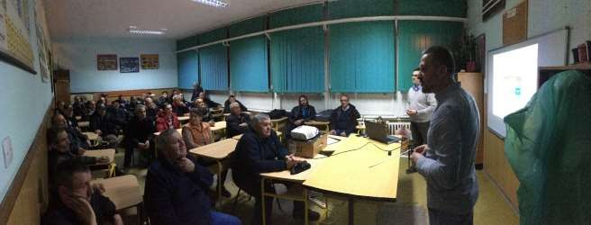

**Photo 4 – Photos from the presentation**